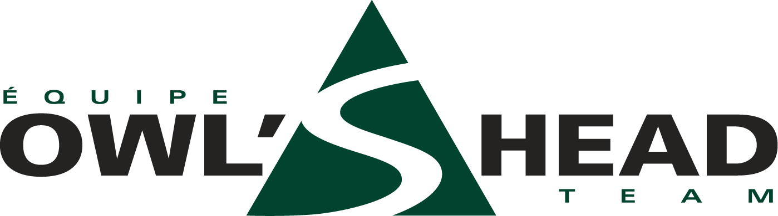

ALUMNI DINNER AND SKI DAY

Dear Present Members and Alumni Parents and Racers,

Welcome one and all to the very first
OWL’S HEAD DINNER AND SKI DAY.
Greet old friends, swap ski stories, test your creaky legs... Enjoy dinner at Louis’. Meet the new members and executive. Learn all about the new parabolic skis and how to use them. Test your newfound skills in a fun race.

Dates: Saturday, March 18, 2000

Sunday, March 19, 2000

SATURDAY 7:00pm
Dinner at “ La Vieille Bûche” Onion Soup gratinée
Caesar Salad Stuffed Breast of Chicken
Dessert and Coffee $26.50 including taxes and tip

Prizes

Special Guest Speaker

SUNDAY 10 A.M.
Clinic with Norm: “Carving with Parabolic Skis”

SUNDAY 1:00 P.M. Timed Fun Race on “Shady Lady”

Reply by March 11th
Peter Owen
(H) 514- 481-5293 (O) 514- 844-5369 (c) 450.292.3562 peteowen@total.net

